* First model:
  + Generate constant FOI from incidence data stratified by age
  + Then use the FOI to generate cases, Incidence rate, mortality, disability, DALY.
  + Details methods:
    - When generate FOI, pop of each country was used => too large => use rho: reporting rate
    - Different scenarios were different by population and defined as:
      * Campaign: $population of 15 age groups of 1 year*vaccine coverage$ = > sequence year defined by the result of last year shift 1 to below.
      * Routine: $population of first age group 00-01*vaccine coverage$ => sequence year was defined by the product of last year shift 1 to the left
    - Generate annual cases by: $\left(1-e^{-λ}\right)*exp⁡(-a*lambda)*ρ*population$ ( $ρ$ is reporting rate)
    - Reporting uniform(1/500, 1/250)
    - Mortality: $cases*uniform(0.1,0.3)$
    - Disability: $survive cases*uniform(0.3,0.5)$
    - DALY: $YLL+YDL_{acute}+YDL_{chronic}=72*mortality+survive cases*uniform\left(0.012, 0.024\right)+disability*uniform(1.43,44.5)$
      * DALY calculate based on these 2 tables:
        + 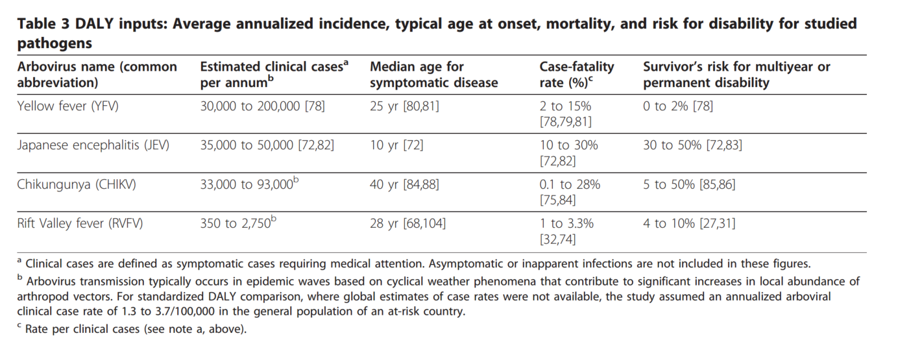
        + 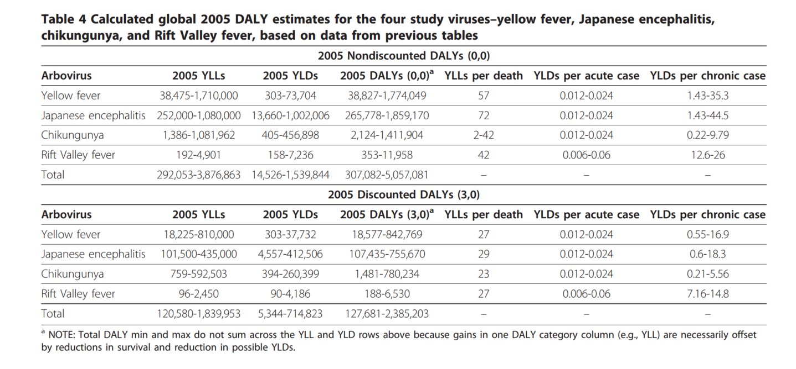
  + Results: our estimation is lower compared to Campbell 2011 => may due to not good fit model (in Cambodia) and wrong risk population (in Indonesia).
* Montagu data refine and interpret:
  + Code in :JEV_Montagu_data
  + Use the code to generate the dataset of pop based on different scenarios:
    - No vaccination
    - Routine
    - Campaign (+ Routine)
  + An example output:
    - Naïve Demo data

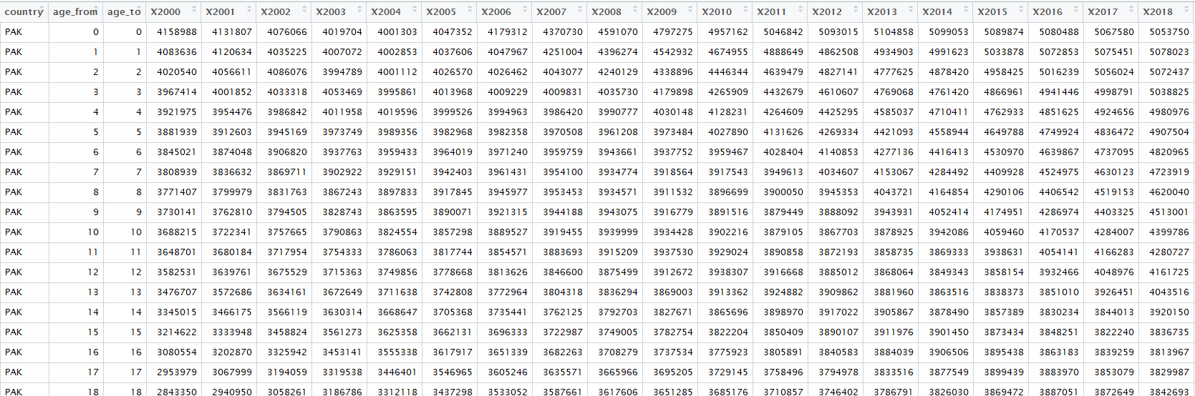

* Cam data:
* 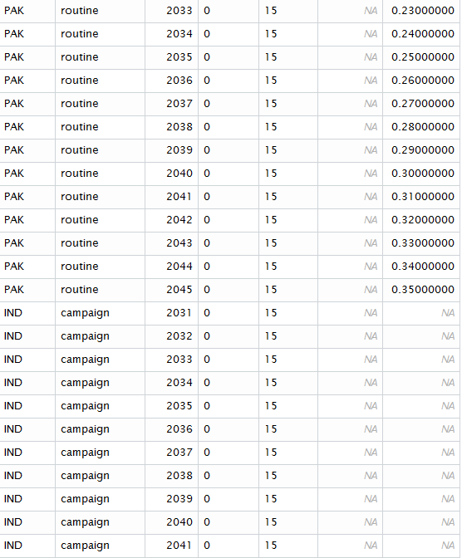
* Rou data:
* 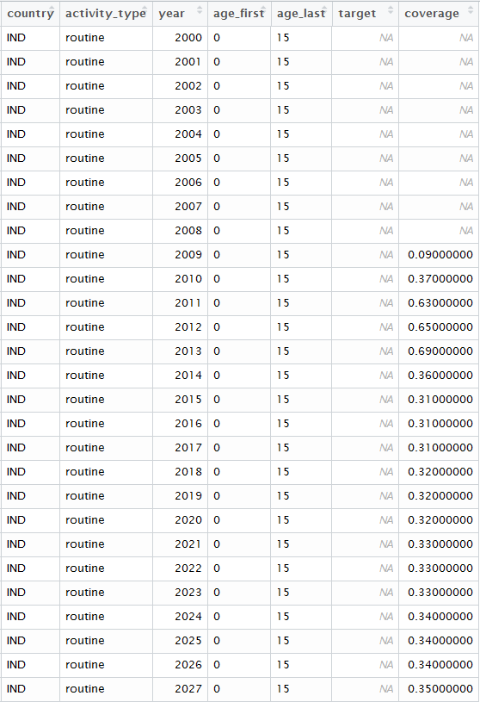
  + Queries:
    - Campaign scenario: the combination of both cam and rou? Also inspecting the target population
    - Routine scenario: the coverages are for all age group? Should it be a routine vaccination in age group 1 ?
  + Current set up for the demographic data:
    - Routine scenario: vaccinating the age group from 0 to 1 year old. The model also takes account the aging vaccinated ppl each year after.
    - Campaign scenario: vaccinating the age group from 0 to 15 year old. The model also takes account the aging vaccinated ppl each year after. Also + the routine scenario. If the years of campaign vaccination are close enough, the sequenced programs will vaccinate the unvaccinated ppl (the leftover) from the previous programs => best estimation scenario.
* Incidence data to generate FOI: (code in JE_cases_model-Montagu_data_and_template)
  + Based on Campbell 2011:
    - India:
      * Lowest incidence:
        + North-west: Haryana, Punjab
        + => group B => get info from group A: Japan
      * Medium incidence:
        + South: Andhra Pradesh, Goa, Kerala, Karnataka, Maharashtra, Pondicherry, Tamil Nadu
        + => group H => data from Malaysia. But data from Mal is unavailable => use this data: India_Japanese encephalitis in Tamil Nadu (2007-2009).
      * High incidence:
        + North-central and north-eastern: Assam, Bangla [West Bengal], Bihar, Manipur, Uttar Pradesh. => group F => data from Nepal (non-west Terai)
    - Parkistan: => group B => get info from group A: Japan
    - Result:

|  |  |  |  |  |  |
| --- | --- | --- | --- | --- | --- |
| Country | Sub group | Cases | Incidence rate/previous est | lambda | rho |
| India | Lowest | 0.146(0.084-0.224) | 0.013(0.0075-0.02)/0.001 (<15) | 0.0002572152 (All age) | 0.0746895895  (All age) |
|  | M-H | 45(27-60) | 0.637(0.124-1.558)/4.7 | 0.284186668 (0-18) | 0.001750758  (0-18) |
|  | High | 135(75-225) | 2.16(1.19-3.55)/5.1 | 0.08384097 (All age) | 1.782843e-05 (All age) |
| Pakistan |  | 0.117(0.069-0.179) | 0.013(0.0075-0.02)/0.001 (<15) | 0.0002311688  (All age) | 0.0845301069  (All age) |

* + - Result with reporting rate sample from uniform(1/500,1/250):

|  |  |  |  |  |  |
| --- | --- | --- | --- | --- | --- |
| Country | Sub group | Cases | Incidence rate/previous est | lambda | rho |
| India | Lowest | 11(0.00046885575-90) | 1(5e-05-9.77)/0.001 (<15) | 0.0002572152 (All age) | 0.0746895895  (All age) |
|  | M-H | 75000(12000-140000) | 1083 (166-2018)/4.7 | 0.284186668 (0-18) | 0.001750758  (0-18) |
|  | High | 23000(13000-36000) | 363(208-565)/5.1 | 0.08384097 (All age) | 1.782843e-05 (All age) |
| Pakistan |  | 0.117(0.069-0.179) | 0.013(0.0075-0.02)/0.001 (<15) | 0.0002311688  (All age) | 0.0845301069  (All age) |